Appendix S1
Results for different measures of functional divergence
We measured functional divergence (FD) in two ways, firstly as Rao’s Q of body mass (FD_{mass}) and secondly as Rao’s Q of body mass, diet, microhabitat, activity time, and leg development (FD_{multi}). Results were very similar using both approaches. More than 50% of significant pathways were shared between FD_{mass} and FD_{multi} models at 50x50km resolution and more than 60% at 25x25km resolution. The relative importance of significant pathways was also high between models was high (Pearson’s r of 0.6 between standardized pathway coefficients). Typically, the environmental predictors of FD maintained their relationships and relative importance (as measured by the standardized pathway coefficients) regardless of which measure of FD was used (Fig. S1.1).
There are some exceptions to this, for example in the gymnophthalmids, net primary productivity (NPP) is the only significant (positive) predictor of FD_{mass} but aridity is the only significant (negative) predictor of FD_{multi.} These differences are qualitatively similar, because, while not interchangeable, regions with high NPP are typically not arid and non-arid places are often highly productive. In other cases, we see changes in whether environmental variables directly or indirectly effect species richness. Temperature is a positive predictor of species richness in anguids, when the model is fit with FD_{mass}. When we fit the model with FD_{multi}, temperature is indirectly related to species richness through its direct relationship with FD_{multi}. In both cases, temperature is an important predictor of species richness, but how we interpret its effect changes with the different measure of FD.

Only in one case do we sign a difference in sign between FD_{mass} and FD_{multi}. This is for the relationship between FD and species richness in geckoes which is positive in when measured using FD_{mass} and negative when measured using FD_{multi}. However, in both cases the relationship is between FD and species richness is relatively weak compared to other pathways in the model.

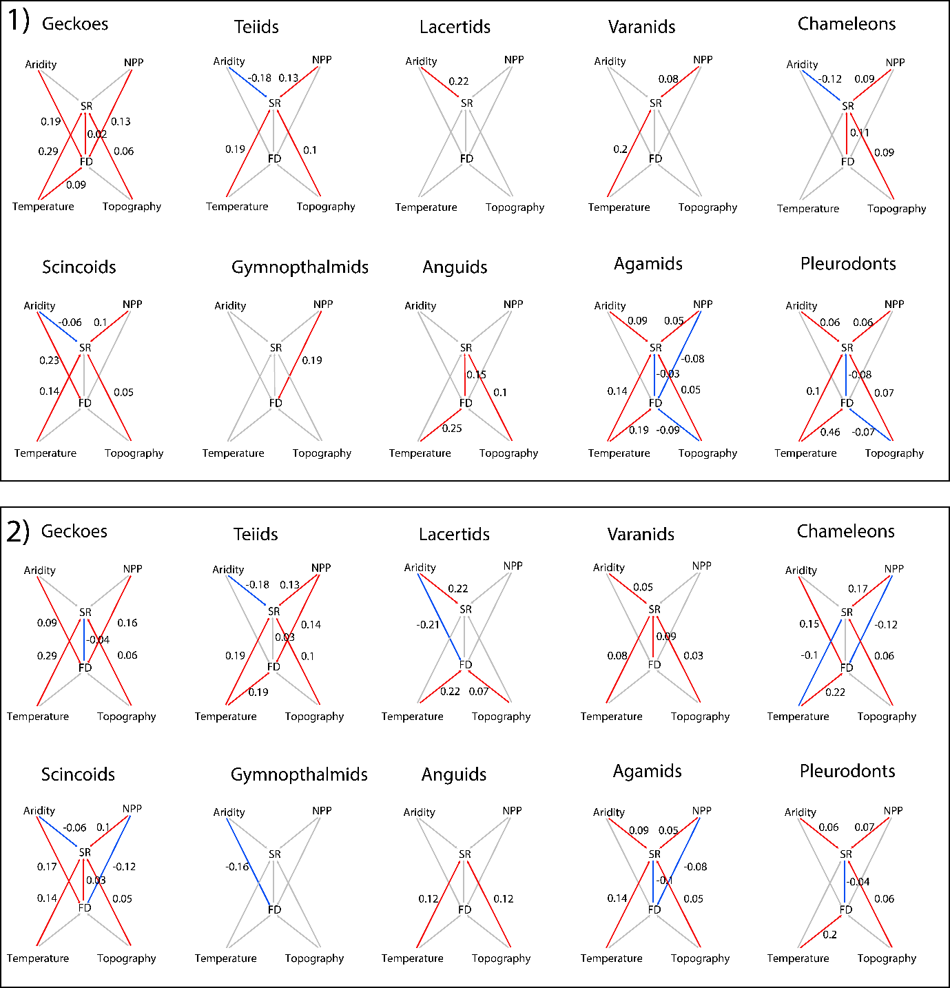
Figure S1. 1. Pathways in piecewise structural equations models of species richness (SR) and functional divergence (FD). All variables were extracted and calculated at a spatial resolution of 50x50km. Panel 1 shows the models for when FD is calculated as the standardized effect size of Rao’s Q for a single trait, body mass, whereas panel 2 shows for when FD is calculated as the standardized effect size of Rao’s Q for five traits together, body mass, diet, activity time, leg development, and microhabitat. Colored paths indicate significant pathways in the final model which were chosen using tests of d-separation and comparing goodness of model fit, while grey pathways indicate excluded pathways from the final model. Red pathways indicate positive standardized coefficient estimates for the pathway and blue pathways are negative coefficients, with coefficient values next to the paths.
Results at different spatial resolutions
We also found that results were consistent when variables were measured at 25x25km resolution and 50x50km resolution. Roughly 50% of all significant pathways were shared between models at different spatial resolutions and the standardized pathway coefficients showed a positive correlation (Pearson’s r = 0.75 for FD_{multi} and r = 0.67 for FD_{mass}). Typically, the strongest environmental predictors of species richness were the same between spatial resolutions, whereas pathways with weak effect sizes (standardized pathway coefficients close to zero) were more variable between spatial resolutions. For example, the importance of temperature as the strongest predictor of species richness is the same at both spatial scales. This suggests that identifying the strongest predictors of species richness were robust to spatial resolution, however the ordering of variables with weaker relationships to species richness is sensitive to spatial resolution. The major differences between spatial scales were the relative importance of functional divergence (FD). At finer resolution (25x25km) FD is a predictor of species richness in nine clades for FD_{multi} and eight clades for FD_{mass} (Fig. 1.2), compared to five clades each at 50x50km resolution. There could be several reasons for this. Firstly, we expect the role of ecological interactions to be stronger at finer spatial scales and we also might expect species richness patterns to be more closely tied to patterns of functional diversity. Alternatively, it could be an artifact of the data, because if the spatial data (measured as broad spatial polygons) is less precise at finer spatial scales we might overestimate the number of co-occurring species which could inflate the degree of divergence we estimate in an assemblage. More work still needs to be done to estimate how spatial precision affects our estimates of community assembly and functional diversity metrics.

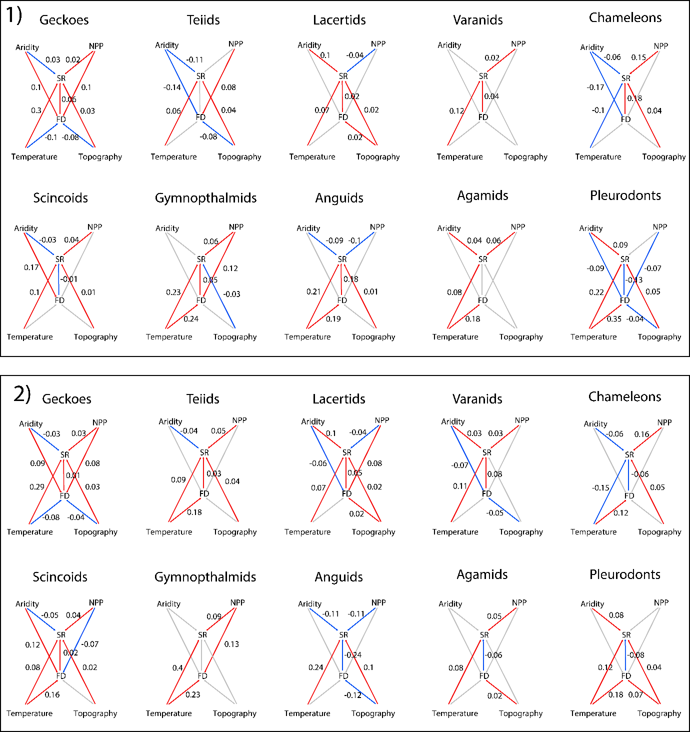
Figure S3. 2. Pathways in piecewise structural equations models of species richness (SR) and functional divergence (FD). All variables were extracted and calculated at a spatial resolution of 25x25km. Panel 1 shows the models for when FD is calculated as the standardized effect size of Rao’s Q for a single trait, body mass, whereas panel 2 shows for when FD is calculated as the standardized effect size of Rao’s Q for five traits together, body mass, diet, activity time, leg development, and microhabitat. Arrows show all pathways in the full model. Colored paths indicate significant pathways in the final model which were chosen using tests of d-separation and comparing goodness of model fit, while grey pathways indicate excluded pathways from the final model. Red pathways indicate positive standardized coefficient estimates for the pathway and blue pathways are negative coefficients, with coefficient values next to the paths.
Appendix S2.
Spatial Autocorrelation
Found in Table_2_2.csv
Table S2.1. Akaike information criterion (AIC) and pseudo-R² (Nagelkerke’s R²; NK) for ordinary least squares (OLS) and spatial autoregressive models (SAR) of species richness ~ functional divergence and four environmental predictors, as well as functional divergence ~ four environmental predictors, with different spatial weights matrices based on different neighborhood distances (distance) and weight coding schemes. W= row standardised, C = globally standardised, and S = variance stabilising. Results show repeated analysis at 25x25km and 50x50km spatial scales as well as when functional divergence was measured for asingle trait (FD_{mass}; body mass) and as multiple traits (FD_{multi}, body mass + diet + microhabitat + activity time + leg development).
Figure S2.1. Autocorrelograms of spatial autocorrelation, measured as Moran’s I, in the residuals of four models for each of ten clades. The models were two ordinary least squares models and two spatial autoregressive models using a row standardized weighting scheme with a neighborhood distance of 250km; 1) Species richness ~ four environmental predictors + functional divergence, 2) functional divergence ~ four environmental predictors.
- Geckoes

- Scincoids
- Teiids
- Gymnophthalmids

- Lacertids

- Anguids

- Varanids

- Agamids

- Chameleons

- Pleurodonts

Appendix S3
Phylogenetic Signal
Table S3.1. Phylogenetic signal, as measured using Pagel’s λ, for five traits in ten lizard clades. Eight traits were not variable within clades (-), 37 out of 42 traits showed significant phylogenetic signal (* p < 0.05), and eight traits did not show significant phylogenetic signal, though many of these contained a very small proportion of species exhibiting different character states (nearly zero variation).

Clade | Body Mass | Activity Time | Micro Habitat | Diet | Leg Development
Geckoes | 0.89* | 0.72* | 0.78* | 0.11* | 1*
Scincoids | 0.95* | 0.89* | 0.85* | 0.88* | 0.98*
Teiids | 0.85* | 0.88* | 0.84* | 1 | 1*
Gymnophthalmids | 0.84* | - | 0.83* | 0.88* | -
Lacertids | 0.83* | - | 0.74* | 0.71* | -
Anguids | 0.81* | 0.44* | 0.75* | 1 | 1*
Varanids | 0.91* | 1 | 0.93* | 1* | -
Agamids | 0.93* | 0.9 | 0.92* | 0.83* | -
Chameleons | 0.94* | 1 | 0.6* | 0.73* | -
Pleurodonts | 0.91* | 0.42* | 0.68* | 0.76* | -

Appendix S4
Data and R code to perform analyses presented in this study.

